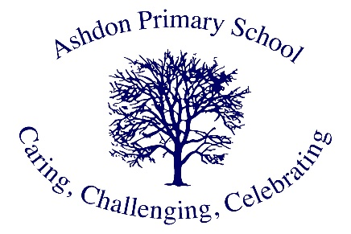

Ashdon Primary School
Geography Vision

At Ashdon Primary, Geography helps us learn about our world and our place in it. We want our pupils to be curious about the places around them and to understand how our world works, from our local village of Ashdon all the way to distant countries.

Through our well-planned Geography lessons, we help our pupils become keen explorers who understand both their local area and the wider world. We believe that knowing about Geography helps our pupils get ready for life in today's world, helping them understand how people and places are connected.

Our Geography teaching is built on these important ideas:
Learning Through Discovery
We learn best by exploring. Our pupils go on field trips in our local area and further afield, where they can see Geography happening in real life. We encourage them to ask questions and find out answers about the world around them.

Looking After Our World
We help our pupils understand why it's important to look after our environment. They learn about how we can protect our planet and make it better for everyone's future.

Understanding Different Places and People
We learn about different places and how people live around the world. This helps our pupils respect and value different ways of life, making them caring citizens of our world.

Learning Useful Skills
We teach our pupils important skills like reading maps, understanding weather, and using computers to study places. These skills help them make sense of our changing world.

Thinking Carefully About Places
We encourage our pupils to think about why places are the way they are, and how we can make them better. We want them to form their own ideas about looking after our environment.

Through our teaching, we want to develop pupils who:
- Feel confident talking about places and how they work
- Think carefully about how to look after our environment
- Know how to study places and find out about them
- Understand why it's important to care for our world
- Are interested in different places and people
- Make good choices about how they affect the environment

We believe Geography isn't just about classroom learning. It's about understanding our world so we can help make it better.
We make our lessons fun and meaningful by:
- Using computers and technology
- Learning outdoors
- Solving real-world problems
- Making links to our local area
- Looking at real examples from around the world

At Ashdon Primary, we're working together to help our pupils understand their world better, from our village to the furthest corners of the Earth. We want them to feel ready to play their part in looking after our world for the future.

