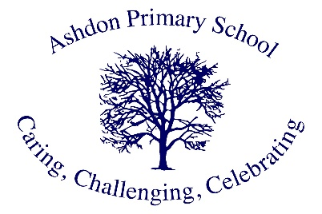

Ashdon Primary School
Mrs. Reynecke- Raybould

Hi there, I am Mrs. Reynecke-Raybould and the headteacher of Ashdon Primary School. I am pleased that you are looking at our wonderful school’s website. I hope that you have found a thing or two that you enjoyed exploring. I grew up in South Africa but have almost been here in lovely ‘sunny’ England for 21 years. I have been in education in England since 2003 and loved every moment of the journey. My time at amazing Ashdon has kicked off in March 2023 and my journey is just getting more and more interesting.
At Ashdon I particularly love that we embrace our school values on a daily basis showing care and respect for one another through using our words and actions, by narrating the positive. Challenge is very important as it gives one a feeling of purpose and then achievement, educationally, mentally, socially, personally etc. Celebrating successes of our pupils is probably the most important part of our values. This happens in a variety of ways, through our weekly newsletters, posts on our school website, weekly celebration assemblies, verbal feedback/over the shoulder marking, Dojo points, house points and of course my favourite, handing out stickers when pupils show of their work with pride.
The vision for our school is that we would like every young person to leave our school with the appropriate tools to carry on their academic journey which will be a stepping stone to become whatever they want to when they are older or attend any university of their choice. This can only be achieved by staff that are truly dedicated to the pupils of the school. Something I am proud to say, we have!
If you get to know me better, you will find that I like to be positive, working hard, love animals (especially dogs) and that having a laugh a few times a day, make the world a much better place.

