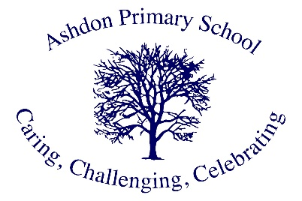

Ashdon Primary School
Mrs. Collins

Hello, I am Mrs Collins and I currently teach Class 1 on a Monday at Ashdon Primary School. I have been at this wonderful school for a year now but have been in teaching for 10 years. I was lucky enough to spend most of my childhood right here in Ashdon. We moved into the village when I was 10 years old, and although I didn’t attend Ashdon Primary school, my younger brother did from year 2 and my mum spent many years at Christmas time performing at the Ashdon Pantomime right here! So, visiting the school is a wonderful memory of mine. After studying Geology at University, I moved down to Brighton and found myself there for 10 years, in which time I got married and started a family! We then made the move back into the area in 2023 and love living locally to family again. At Ashdon, I love how much of community we are, and how the children really endorse this spirit within the school. Every child cares about one another and will always look out for every individual in our school. We also love to celebrate eachother’s achievements through verbal feedback, celebration assemblies and class celebrations. My belief is that all children should strive to achieve their very best and the staff are there to facilitate this and to ensure every child is heard. I love spending time with my loved ones, family days out, walks, food and having a good giggle!

