
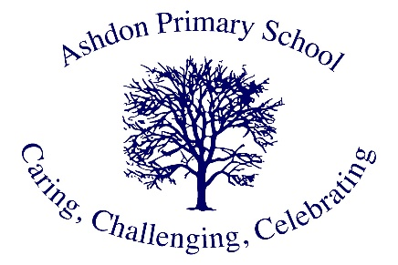
Ashdon Primary School
Science Vision

Our Vision for Science
At Ashdon Primary School, our children are scientists! We believe that every child has the potential to be curious, creative and analytical in their approach to understanding the world around them. Our vision is to nurture these natural qualities through an inspiring and engaging Science education that opens doors to endless possibilities.

Why Science Matters at Ashdon
Science is fundamental to our pupils' understanding of the world. It encourages them to question, investigate and discover, developing critical thinking skills that will serve them throughout their lives. Through Science, our pupils learn to:
- Think analytically and solve problems
- Develop curiosity about the natural world
- Understand how scientific discoveries shape our daily lives
- Build confidence in their ability to investigate and explore
- Work collaboratively and share ideas
- Connect their learning to real-world applications

How We Achieve Our Vision
Our approach to Science teaching and learning is built on:

Engaging Learning Experiences
We provide hands-on, practical experiences that bring Science to life. Our pupils are active participants in their learning journey, conducting experiments, making observations, and drawing conclusions from their findings.

Progressive Skill Development
From Early Years to Year 6, we carefully build scientific knowledge and skills. Each year of learning builds upon previous understanding, creating confident and capable young scientists.

Real-World Connections
Through educational visits, expert visitors, and real-world examples, we help our pupils understand how Science connects to their daily lives and future opportunities.

Inclusive Approach
Every child can be a scientist. We ensure our Science curriculum is accessible to all pupils, providing appropriate support and challenge to enable every child to succeed.

Our Aspirations for Our Pupils
We want our pupils to:
- Leave Ashdon with a deep love for Science
- Feel confident in their ability to think scientifically
- Recognise their potential to contribute to scientific discovery
- Understand how Science shapes our world
- Be inspired to consider careers in Science
- Carry their scientific curiosity into secondary education and beyond

Building for the Future
We are committed to continuously developing our Science provision, staying current with scientific developments and educational best practices. Through our partnership with the Hamilton Trust and ongoing professional development, we ensure our Science teaching remains dynamic and effective.
Our vision is not just about teaching Science – it's about inspiring the next generation of scientists, engineers, doctors, and innovators who will shape our future world.

Measuring Success
We know our vision is being realised when we see:
- Enthusiastic engagement in Science lessons
- Confident use of scientific vocabulary and methods
- Thoughtful questions and independent investigations
- Pride in scientific achievements
- Positive feedback from pupils and parents
- Strong progress in scientific knowledge and skills
- Pupils choosing to pursue scientific interests beyond the classroom

Through this vision, we aim to establish Ashdon Primary School as a place where scientific thinking flourishes and where every child's potential as a scientist is recognised and nurtured.

