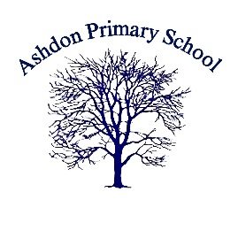

**Ashdon Primary School**

**Bartlow Road**

**Ashdon**

**Essex**

**CB10 2HB**

**Tel: 01799584219**

**Email: admin@ashdon.essex.sch.uk**

Dear parents/carers

**James Campbell Author Visit Wednesday the 30th of April 2025**

We will be visited by James Campbell on Wednesday the 30th of April 2025, James is a children’s author, storyteller and comedian. James has written books such as The Funny Life of Football, The Umbrella Tree and Don’t Panic! We can save the planet. James will be spending the whole day in school visiting each class throughout the day to inspire children to be more creative with their writing.

James will also be hosting an after school book selling event, James will be signing books for you to purchase in the school hall from 3.30pm on Wednesday the 30th of April please collect your child as normal from the courtyard and make your way to the school hall via reception please read the attached letter for further details.

**We are asking for a voluntary contribution of £5 per child towards the cost of this visit payment can be made online using your SCO payment account. If your child is in receipt of pupil premium funding this visit will paid for via this fund.**

Kindest regards

Mrs Reynecke - Raybould