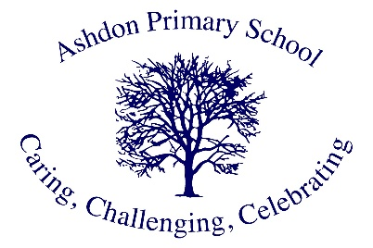

Ashdon Primary School
Mrs. Dowding

Hello! My name is Mrs Dowding and I have been the Higher-Level Teaching Assistant at Ashdon for two years now.
I have spent over twenty years in education; partly as learning support, but mainly teaching. My role at Ashdon is to cover teachers’ release time from class. As Computing lead, I teach ICT, but can teach everything from sewing to French! As an HLTA, I have the privilege of being involved in your child’s learning and getting to know all the children from EYFS to Year 6. But of course, their learning doesn’t stop there - I am a great believer in ‘lifelong learning’, something I’m keen to convey to the children at Ashdon. To instil a good work ethic, promote a kind and caring environment, and showing respect, are all part of the ethos of Ashdon; acknowledging and celebrating success encourages our children to shine.
I love working at Ashdon!

