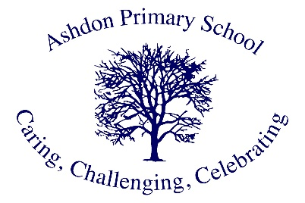

Ashdon Primary School
Mrs. Allen

I'm Mrs Allen and have been part of the Ashdon Primary School team since June 2008 and I still love it!
All four of my children attended and flourished at the school, I appreciated the family, nurturing feel they experienced and now being on the 'other side' I strive to continue this in my work.
I have worked across the whole school, with every class and year in a variety of roles but keep bouncing back to the youngest children who I especially enjoy working with. Having said this I also value my Learning Mentor role which tends to be with the older children, encouraging, supporting and on occasion challenging them.
On a personal level I enjoy warm (not hot!) sunshine, laughing hard, cake and reading.

